Christian
Wellness
Coaching


Rick Mautz PT, MS
rickm@rmcsda.org

Syllabus Contents

Reference Pages
3 A Personal Work
7 Quotations for a personal work
8 How to Understand Bible Promises
9 Bible Promises
11 Therapeutic Communications
12 Coaching Partnership
13 Step by Step Getting Ready
14 First Coaching Sessions Checklist
15 Vision (Dream) – Planning Tool
16 My Wellness Vision Form
17 Vision and 3 Month Goals Instruction
18 Step by Step – Weekly Coaching Sessions
19 Weekly Coaching Checklist
20 Coaching Weekly Worksheet
21 Two Week Goals Form
22 Coaching Do’s & Don’ts
23 Systematic Coaching Questions
27 Coaching Behavior Change Pyramid
28 Basic Coaching Communication Skills and Tools
29 Discovering Their Needs
31 Coaching Inquiry and Awareness
32 Sample Questions For Coaching Inquiry
33 Motivational Coaching
36 Sample Questions for Ambivalence or Resistance
37 Sample Coaching Questions
38 Creations Health
39 Health Principles in Wellness Coaching
40 Key Health Principles
42 Quick Tips in Coaching Exercise and Nutrition
43 Quick Tips in Coaching Stress and Spiritual Areas
44 Sample Spiritual Questions
45 Coaching Resource Car

Personal Work As Applied in Coaching

A Personal Work

Christ’s most important and precious work for His people is to represent Him in their daily lives. To present a picture of what Christ is, His love and how he would treat us if He were here today. We are to be his hands and feet and heart to the world. Many do not trust Him only because they do not know Him.3

Different types of work provide varying degrees of opportunity to reveal Christ. The one that Christ often utilized in His ministry was coming close to the people and helping them to find health of body, mind and soul and bring relief from physical suffering. Over 100 years ago this was called Medical Missionary work. The name itself may not describe the work for today but the concept is just as important. We read statements regarding this type of work that raise it to a level of “the most important”, “the right arm”, “the door for truth”, “the signature of heaven”. “I wish to tell you that soon there will be no work done in ministerial lines but medical missionary work.” CH 533. When reading about medical missionary work the idea of a personal work, coming close to the people to bring wellness to body, mind and soul is repeated over and over, a work that any can do not just trained professionals.

God has blessed our church with clear instruction on how to be most effective in reaching our world and particularly in these last days. What I see in scripture and through his prophetic gift is Gods character being revealed through the lives of those working closely with individuals from day to day but especially as they help them toward wellness. “ The world needs today what it needed nineteen hundred years ago – a revelation of Christ … Christ’s method alone will give true success … there is a need of coming close to the people by personal effort.” MH 143.

We as a church are known for our health work and it has been effective. We have built large facilities, we have developed live in health centers, we hold many programs for people to come and listen to information regarding health and we count our success by how many attend our programs or how many facilities we operate. but the results in changed lives does not reach the magnitude predicted in these quotations. There is much emphasis on the big programs and little on the one-on-one which, in my opinion is the most important for our success. Information seldom leads to lasting change without the personal support of a caring friend to support and encourage.

The evangelistic work in all parts of the world as well as here in North America is often not as effective as we would like. Many times there are large numbers who accept the teachings that are presented and are even baptized but soon leave the church and return to their previous lifestyle. What God demonstrated when He sent His son and later the Comforter to help us, was that we need personal help to make changes in our life. Instead of just giving information we need to learn how to reveal Christ through personal help work. Assisting others to make the changes in their life that they long for, to help them set and reach goals through encouragement and in sharing with them the source of real power for success. Then we would experience in our churches what many are longing for, the power to live a healthy and happy life growing into the image of Christ

Coaching
When I became aware of Wellness Coaching I began to see how Gods people can help others in a powerful and personal way to reach their goals for a better life. The principles are those used by Christ, whether or not the organizations doing the training realized it. Maybe that is why the modern coaching movement is finding such success.

Coaching is a partnership between a coach and an individual in the community or church, who desires to make changes in his/her lifestyle; prayerfully walking together over a set period of time. This interactive ministry moves individuals from information to action in this partnership. Wellness coaching is an innovative, biblical way to build supportive relationships so that participants experience sustainable lifestyle change. It is not therapy or counseling. A wellness coaching approach helps individuals make healthy lifestyle changes that are holistic because the body mind and spirit are intrinsically intertwined. The Spirit's presence prior to and during each interaction is essential, opening both minds to Christ's will. This approach is effective as it follows Christ's method of working with people.

A coach does not need to have medical training, but a coach needs to learn to really listen and through powerful questions help their client find their own answers for reaching their goals. There are a variety of coaching roles that a person can fill. From the simplest plan of being available to walk with a neighbor who needs that simple encouraging support. Or they may become skilled to the point where they can do this as a profession. There are some that have taken our coaching classes that have found the listening and communication skill very valuable in their daily life as they relate to their own family and friends. Those in our churches that have a burden for souls can be trained in a short time to be an effective Wellness Coach.

There are three main areas of training needed for a balanced coach, even though some who take advantage of this training may already have skills in any or all of these topics. The first is an understanding of the spiritual dimensions of total health. Knowing what should come first in a healthy journey. Grace and works must be understood to avoid some of pitfalls of the past. They must understand the way to weave in the spiritual appropriately following Christ’s methods of mingling, win confidence, meet their needs and then bid them to follow Him. The Second is the skill of coaching. Along with many other skills coaching involves good listening skills and asking the right questions to guide a person to the steps that will help them reach the goals they have decided on. This is the way that Jesus taught and helped people to change their lifestyle and heart. The third is to understand basic health principles including: basic nutrition concepts, appropriate exercise, the use of the eight natural remedies to preserve and regain health. They need to be aware of dangers and to know when other professional help is required, how to refer to others that can help such as professional counseling or medical care. Like a next door neighbor who is there to encourage you but not take the place of a medical professional.

As I have worked in the medical profession and the health education arena it has become clear to me that we have done well with training of physicians and teachers but have not trained the most important part of the team, the one that comes alongside and helps to put all that knowledge the health professional has been sharing into practice through a personal relationship and caring heart.

In combination with a plan for evangelism or within the spirit of ongoing evangelism must come personal ministry.. We must start with an attitude of benevolence, of wanting to help relieve suffering and help restore people to image of Christ without an expectation of anything in return (even the hope of a baptism). We should be training our members and students in the principles of personal ministry and wherever possible to give more in depth training in coaching skills.

My training has been in coaching for lifestyle changes but the principles can be used for those wanting to make spiritual changes in their life as well. As we stay open to the guidance of the Holy Spirit we will hear where the HS is guiding them as they tell us their dreams and desires for change. Listen and ask questions with a discerning ear and open heart and we will truly do the same work as our great example Jesus Christ. And when His character is perfectly revealed through His people in thought and deed then He will come.

Cooperative
Wherever possible the church and the hospitals need to partner together, both groups benefit in this cooperative effort. Wellness coaches are not stand alone workers, neither do they disparage other health work rather they augment it and support all other work, including: physicians, ministers, health educators, evangelists, hospitals, live-in-centers and their own neighbors.
Various Applications
The Church:
With a group of coaches in a church the church will be stronger and healthier but also with improved communication skills the church will have less internal strife. Then as the coaching is applied to outreach it optimizes all community programs that the church is active in. With trained members there are more active members for any outreach programs.
Hospitals:
Once church members are trained as coaches they will be able to help local hospital to assist their community to reach their health goals.

Live-in Lifestyle Centers:
These centers are fabulous in the personal connection and their ability to help people make changes while in a protected environment with a whole team of dedicated workers. But when their guests return home in many cases the changes made are short-lived due to lack of support at home. I have talked with some of these centers and they would be thrilled to have trained volunteer coaches to follow up with regular calls for support and encouragement, following the instruction given them by the center. Because of the modern communication available much can be done for anyone no mater where they live.
This teams up those church members looking for a meaningful ministry with those who’s hearts are very open to their help both for body and soul. This help will make the difference between failure and a changed life with hope for the future.

Physicians:
Wellness coaches can team up with physicians in their town to assist their patients to make the changes the physician has encouraged. It should be noted that coaching should not counter any instructions give by the health professional remembering that coaching is helping a person reach their goals therefore this would be a welcome change for physicians to have someone helping their patience to reach the goals they have set for them. The doctor doesn’t have enough time to help all his patience like he would like to do. With the patients success through coaching the physicians will be open to other programs that the church and coaches are involved with.

Health Programs:
These programs such as Stop Smoking, Cooking schools, Stress/Depression seminars, Evangelistic Efforts, Health Lectures, CHIP. Turn these efforts from a passive spectator event into a personal learning experience that will continue long after the program is over, with a personal friendship of a coach that will last a lifetime.

With all of our health work, at every level, we are often missing the most critical, foundational component. The personal one on one support of an individual who cares, to make effective the many programs that we are conducting.

It is time to train as many of our members as we can to become personal helpers for the scores of people who want to make a change but don’t know how and at the same time pull many aspects of the work together into a coordinated and effective effort. There may be many ways to do personal work that is critical for preparing the world for His coming but I have seen relationships built stronger and faster through coaching than in any other ministry that I have experienced, but what ever we do we must get busy training and fitting a people to reveal Christ more perfectly to the world today so that He may come.
Quotations for “A Personal Work”

Christ is waiting with longing desire for the manifestation of Himself in His church. When the character of the Savior shall be perfectly reproduced in His people, then He will come to claim His own. It is the privilege of every Christian, not only to look for, but to hasten, the coming of our Lord. Were all who profess His name bearing fruit to His glory, how quickly the whole world would be sown with the seed of the gospel! Quickly the last great harvest would be ripened, and Christ would come. Maranatha 112.5

Dan. 12:6,7 … How long shall it be to the end of these wonders?
... and when he shall have accomplished to scatter the power of the holy people, all these things shall be finished.

I wish to tell you that soon there will be no work done in ministerial lines but medical missionary work. CH 533

Christ's method alone will give true success in reaching the people. The Savior mingled with men as one who desired their good. He showed sympathy for them, ministered to their needs, and won their confidence. Then He bade them, “Follow Me.” MH 142-143

MH 145 Many have no faith in God and have lost confidence in man. But they appreciate acts of sympathy and helpfulness. As they see one with no inducement of earthly praise or compensation come into their homes, ministering to the sick, feeding the hungry, clothing the naked, comforting the sad, and tenderly pointing all to Him of whose love and pity the human worker is but the messenger – as they see this, their hearts are touched. Gratitude springs up. Faith is kindled. They see that God cares for them, and they are prepared to listen as His word is opened.

MM 22 We are now to unify, and by true medical missionary work prepare the way for our coming King.
MM 23 God chose His son to be His representative on the earth, even so has Christ chosen us to represent His character.
MM 28 Christ is willing to unite with His devoted ministers today in healing the sick and suffering.
MH 143 Everywhere there are hearts crying out for something which they have not. They long for a power that will give them mastery over sin, a power that will deliver them from the bondage of evil, a power that will give health and life and peace.
The world needs today what it needed nineteen hundred years ago-a revelation of Christ. A great work of reform is demanded, and it is only through the grace of Christ that the work of restoration, physical, mental, and spiritual can be accomplished.

How to Understand Bible Promises

Bible promises are not a gimmick that God uses, in which he will grant you some great help if you can quote the right text for the right situation and only then will he grant you the promised help. Instead they are statements of fact. They are truth, and when you know truth, a lie looses its power. I lie will temp you only if you think it is true, so when you know the truth the power of the lie is gone.

An example of this is if you saw your child do something he wasn’t to do and later he lied about it. How convincing was the lie? Not at all, because you know the truth.

So as you put the truth (promises) in your mind, when a lie (temptation) comes along it has no power because you know the truth. You only quote the promise to clarify in your mind the contrast of the truth with the lie and confirm that the lie should be discarded and given no more room in your thinking.

David said: Thy law have I hid in my heart that I might not sin against thee. He had memorized truth (law) so when the lie (temptation) came he resisted it with truth (promises) and was a victor over the temptation (sin).

Memorized promises are powerful to win over future lies (temptation).

Bible Promises
And be not conformed to this world: but be ye transformed by the renewing of your mind, that ye may prove what is that good, and acceptable, and perfect, will of God. Rom. 12:2

I have said this to you, that in me you may have peace. In the world you have tribulation; but be of good cheer, I have overcome the world. John 16:33

His divine power has granted to us all things that pertain to life and godliness, through the knowledge of him who called us to his own glory and excellence, by which he has granted to us his precious and very great promises, that through these you may escape from the corruption that is in the world because of passion, and become partakers of the divine nature. II Peter 1:3,4

I have laid up thy word in my heart, that I might not sin against thee. Psalms 119:11

But seek first His kingdom and his righteousness, and all these things shall be yours as well. Matthew 6:33

No temptation has overtaken you that is not common to man. God is faithful, and he will not let you be tempted beyond your strength, but with the temptation will also provide the way of escape, that you may be able to endure it. I Corinthians 10:13

Submit yourselves therefore to God. Resist the devil and he will flee from you. Draw near to God and he will draw near to you. James 4:7,8

The name of the Lord is a strong tower; the righteous man runs into it and is safe. Proverbs 18:10

Now to him who is able to keep you from falling and to present you without blemish before the presence of his glory with rejoicing, to the only God, our Savior through Jesus Christ our Lord, be glory, majesty, dominion, and authority, before all time and now and for ever. Amen. Jude 24,25

For the Lord God helps me; therefore I have not been confounded; therefore I have set my face like a flint, and I know that I shall not be put to shame; he who vindicates me is near. Who will contend with me? Let us stand up together. Who is my adversary? Let him come near to me. Isaiah 50:7,8

I have been crucified with Christ; it is no longer I who live, but Christ who lives in me; and the life I now live in the flesh I live by faith in the Son of God, who loved me and gave himself for me. Galatians 2:20

For because he himself has suffered and been tempted, he is able to help those who are tempted. Hebrews 2:18

Be sober, be watchful. Your adversary the devil prowls around like a roaring lion, seeking some one to devour. Resist him, firm in your faith, knowing that the same experience of suffering is required of your brotherhood throughout the world. I Peter 5: 8,9

You are of God, little children, and have overcome them, because He who is in you is greater than he who is in the world. I John 4:4

Blessed is the man who endures trial, for when he has stood the test he will receive the crown of life which God has promised to those who love him. James 1:1

I say then: Walk in the Spirit, and you shall not fulfill the lust of the flesh. Galatians 5:16
Therefore, if anyone is in Christ, he is a new creation; old things have passed away, behold, all things have become new. II Corinthians 5:17

For we do not have a High Priest who cannot sympathize with our weaknesses, but was in all points tempted as we are, yet without sin. Let us therefore come boldly to the throne of grace, that we may obtain mercy and find grace to help in time of need. Hebrews 4:15,16

And let us not grow weary while doing good, for in due season we shall reap if we do not lose heart. Galatians 6:9

Be anxious for nothing, but in everything by prayer and supplication, with thanksgiving, let your requests be made known to God; and the peace of God, which surpasses all understanding, will guard your hearts and minds through Christ Jesus. Philippians 4:6,

We are hard pressed on every side, yet not crushed; we are perplexed, but not in despair; persecuted, but not forsaken; struck down, but not destroyed. II Corinthians 4:89

"Let not your heart be troubled; you believe in God, believe also in Me. Peace I leave with you My peace I give to you; not as the world gives do I give to you. Let not your heart be troubled, neither let it be afraid." John 14:1,27

But now, thus says the Lord, who created you, O Jacob, and He who formed you, O Israel: "Fear not, for I have redeemed you; I have called you by your name; you are Mine." Isaiah 43:1

Therefore humble yourselves under the mighty hand of God, that He may exalt you in due time, casting all your care upon Him, for He cares for you. I Peter 5:6,7

"Fear not, for I am with you; be not dismayed, for I am your God. I will strengthen you, yes, I will help you, I will uphold you with My righteous right hand." Isaiah 41:10

When you pass through the waters, I will be with you; and through the rivers, they shall not overflow you. When you walk through the fire, you shall not be burned, nor shall the flame scorch you. Isaiah 43:2

For I am persuaded that neither death nor life, nor angels nor principalities nor powers, nor things present nor things to come, nor height nor depth, nor any other created thing, shall be able to separate us from the love of God which is in Christ Jesus our Lord. Romans 8:3839

"See, I have inscribed you on the palms of My hands; your walls are continually before Me." Isaiah 49:16

For in that He Himself has suffered, being tempted, He is able to aid those who are tempted. Hebrews 2:18

Yet in all these things we are more than conquerors through Him who loved us. Romans 8:37

But each one is tempted when he is drawn away by his own desires and enticed. James 1:14

For whatever is born of God overcomes the world. And this is the victory that has overcome the world, our faith. Who is he who overcomes the world, but he who believes that Jesus is the Son of God? I John 5:4,5

And my God will meet all your needs according to His glorious riches in Christ Jesus Phil 4:19

I can do everything through Him who gives me strength. Phil.4:13.

Blessed is the man who does not walk in the counsel of the wicked or stand in the way of sinners or sit in the seat of mockers. But His delight is in the law of the Lord. Psalms 1:1,2.
Great peace have they who love your law, and nothing can make them stumble. Psalms 119: 165. NIV

Therapeutic Communications

Comparison of approaches: Professional Counseling or therapy should not be done in coaching. With their permission, resources or referrals can be offered.

 | Teaching | Mentoring | Counseling | Coaching **
Content | Information | Character skills, information, vision | Emotional and relational problems | Listen, reflect, questions, encouragement
Purpose | Learning information | Develop the Individual | Resolve emotional and relational problems | Personal growth and development
Role | Impart information | Reproduce what you know and do | Guide process for problem resolving | Walk along side, helps them discover direction and resources
Focus | Present | Future | Past | Present & Future

When and How are people changed or transformed…

      - When they experience pain
      - When they are convicted of the need
      - When they observe a more fruitful way
      - When they are grasped by a vision
      - When a Christian FRIEND comes alongside
      - When they are accepted just as they are

** What is coaching and how does it work?

Personal coaching is a proven paradigm for improving athletics and executive performance. It is now used to support health and wellness. Personal trainers exercise the body, coaching exercises the mind. The close personal relationship during coaching conversations by the friend provides others with structure, accountability, expertise and inspiration that enables them to learn, grow and heal beyond what he/she can do alone, even with usual medical support. They take responsibility for their own future.

Using vital skills of mindful listening, powerful questions, accountability and prayer, along with weekly encouraging support, the person being coached feels accepted, respected and moved to achieve and fulfill their deepest desires.

Coaching Partnership

My part

- As your wellness coach is to partner with you over the next two or three months in your plan to improve your wellness.
- Through coaching I will encourage you to identify your wellness vision, motivators, obstacles, as well as strategies to overcome obstacles.
- I will listen to you attentively, without judgment or my own agenda.
- I will ask if prayer for guidance is acceptable to you.
- I will encourage realistic expectations and goals in your wellness plan.
- I will support your creative solutions to get around any roadblocks.
- I will be punctual and responsive and maintain full confidentiality for you and your records.
- I will not offer advice or counsel or do therapy of any kind but encourage your plan.
- I will refer you to another professional if we both agree it would be more beneficial.
- I will be flexible and reschedule appointments as the need arises.
- I will not charge a fee for our time.

Your part

- I can agree that a higher level of wellness brings powerful benefits to me.
- I am ready to take the responsibility to make changes in one or two areas of wellness.
- I will invest in the time of possibly three months to make improvements.
- I will share information that is relevant to my wellness.
- I am open to suggestions and to try new things.
- I understand that setbacks and revisions are normal with change and even necessary to establish new habits.
- I will be punctual and responsive.
- I will ask for support, feedback or resources I need from my coach.
- I will let my coach know if a need develops to alter the scheduling of sessions and the three months

Coach/Mentor:_____________________________
Phone:___________________________________
Email:___________________________________

Step by Step - Getting Ready

Before you begin this journey there are a few steps I would suggest for preparing yourself to do the best work possible.

- Set aside regular time to spend in prayer and study of the master coach. The more you know Him and His ways, the more you learn to rely on his wisdom and strength that He is more than ready to share with you the more you will reflect Him to those whose lives you touch.
- Study Christ’s Methods (This is part of your ongoing study to stay ready)
  - Suggested reading
    - Jesus Life Coach by Laurie Beth Jones
    - Medical Ministry by E G. White
    - Bible stories of Jesus healing methods
- Begin to listen to those around you who are trying to make changes in their lives. While you are getting ready to coach you can start by learning how to be a friend. Start practicing some of the skills of listening and asking caring questions and exploring their life for the sake of helping.
- Understand what a coach is and what they are not. Understand your limitations but also knowing the power of God and the power of friendship.
- You don’t need to have all the skills mastered to start, just the basics.
- Do you have the time to maintain a weekly contact as long as they need you for reaching their goals?

Setting up a Coaching Relationship – Example

- “I understand you are interested in making some lifestyle changes. Change can be difficult, especially on your own, I would be happy to work with you to help you reach your goals. Would you like that?”
- If they agree, ask. “When can we get together to get started, the sooner the better”
- “There are a few things about coaching that you might want to know. First of all my role as a coach is not to just give you advice. Most people know what they need to do. but they generally try to take to big of steps often leading to failure and discouragement. I believe in taking small steps to maintain a steady successful path toward your goal. Will that work for you?”
- “What I have found works best is a weekly coaching call to review progress, talk about the process and gain the skills to continue on the right path.”
- “Be thinking about a time that works best for you on a weekly basis for a coaching call. You will need to allow between 20-30min. each week.”

Plan the first session to allow 45-60 minutes, Using the WORKSHEET, list their phone
number, email address and other helpful notes. Prepare a folder.

(Optional) Send a COACHING PACKET by email or slow mail to jumpstart the relationship.
Assure them that they have full confidentiality when you call.
(Packet includes: Information on how coaching works, a lifestyle overview with ideas to work on and a worksheet for them to list their vision, goals and progress. And some might be able to use the “Personal Log Book”
FIRST COACHING SESSION CHECKLIST
The first session is critical for long lasting trust and rapport. Allow 60 or more minutes.

Before the session
Remember key skills of mindfulness, listening, inquiry and reflection
Pray for the Lord's guidance
Session opening
Welcome and thank you
Determine if the coaching information came and if there are any questions. (optional)
Review agenda and coach credentials and passion
Ask what questions came up after (if) they went over the health evaluation.
Ask what they learned about themselves, gather needed information
Go over the medical history, discuss physician release to exercise if needed. (optional)
Ask their permission to pray for guidance in planning
Create a wellness vision
Explain the value of creating a wellness vision
Ask what is most important right now, what are the hopes and dreams for wellness
Review success stories, identify strengths and what is working now or brings pride
Discover motivators: benefits of making changes now, the driving force behind the desire to change now.
Support them visualizing their vision and describing it in detail
Discover previous positive experiences with elements of the vision & their strengths
Explore the people, resources, systems, environment needed to ensure success
Ask them to state and commit to the vision
Design three month goals
Explain value of three month goals
Ask them to choose three actions that are most important to pursue
Confirm their connection to the wellness vision
Assist them in translating the actions into general goals
Design first week's goals
Ask them to choose one or two actions in their goals to work on
Assist them to design a SMART behavioral goal that is easy, to develop confidence
Explore structures needed to ensure success
Use confidence ruler (0-10) to improve their confidence in reaching the goal
Ask them to restate the goal and affirm their ability to achieve the goal
Session close
Express appreciation for their work, & email or slow mail their vision and goals
Schedule the next session, clarify length of sessions following
Vision (Dream) - Planning Tool

Beginning with the end in Mind : Forward thinking. Ask, “Can we spend a few minutes looking forward?”

A Picture: What does your vision look like? What would you look and feel like at this ideal level of wellness? Be as detailed as you can, written in the present tense as if you were already there.

Key Elements: Highlight the most important parts of your vision. Keep these prominent to stay on track through the process of goal setting and the change process.

Motivators: What makes this vision really importing to you? How does it strengthen your personal core values? What good will come from doing this?

Gap: How big is the gap between where you are today and your wellness vision? How do you feel about it?

Confidence : How confident are you that you can close that gap and realize your vision? (0-10) (not –very) Positive: (if a 7, “why didn’t you say a 5 or 6?”) This gives them an opportunity to give a positive reason why they have confidence. If 6 or less, what would it take to elevate it?

Challenges: What significant obstacles do you anticipate as you begin this journey toward your vision? Describe them. Which ones concern you the most?

Strengths: What strengths can you draw on to help you overcome and reach your vision?

Support: What people, resources, systems and environments can you draw on to help you meet your vision and challenges?

Strategies: What strategies do you see as being effective in meeting these challenges? Brainstorm and clarify several possibilities before narrowing your focus.

The vision will answer:
- Who do I want to be when it comes to health, fitness and wellness.
- What do I want to do consistently, exercising, eating, relaxing.
- What do I want to happen? (stronger, lighter, less stress)
- What’s important to me? What will happen if I don’t change?
Example:
I am walking for exercise consistently. Eating a good, healthy breakfast and lunch every day and a light supper. If I go out to eat I find the best options available. I take time each evening to relax with the Bible or devotional book before retiring.

Respond to these vision plans:
My Wellness Vision

Vision:______________________________________________________________________________________________________________________________________________________________________________________________________________________________________________________________________________________________________________________________________________________
My Motivators __________________________________________________________
__________________________________________________________
My Obstacles __________________________________________________________
__________________________________________________________
My Strategies to overcome my obstacles are: __________________________________________________________
__________________________________________________________
My Support System:
People:____________________________________________________
Organizations:______________________________________________
Clubs:_____________________________________________________________________________
Equipment:_________________________________________________
Etc.:______________________________________________________

My Three Month Goals

Activity:__________________________________________________________________________________________________________________________________________________________________________
Nutrition:____________________________________________________________________________________________________________________________________________________________________
Stress:______________________________________________________________________________________________________________Other:__________________________________________________________________________________________________

Vision, and 3 Month Goals Instruction

First write a VISION of what you wish to be like, what you want to change or accomplish, how you want to feel and why. Example: My vision is that I maintain healthy weight, exercise regularly, eat healthy food and feel less stressed so I can enjoy the time I spend with my family.

A MOTIVATOR is a description of what is important to your personal life that will motivate you and strengthen your commitment to your vision during the program. Example: My primary motivator is to maintain my health and quality of life.

An OBSTACLE is an event or circumstance that may hinder you in achieving your goal. Example: My main obstacle is that in times of high stress I tend to eat sugary snacks and get off track in my plan to lose weight.

A STRATEGY is the method you will use to overcome obstacles.. Example: My strategy to overcome my obstacle is to replace mindless eating by taking a break from what I am doing and take a short walk, or take a few minutes for meditation.

Three Month Goals: Goals are tools that serve your Health Track vision. 3 months are long enough to make progress, experience benefits and establish what you want to be doing consistently for your health. Changes are difficult at first, so two week or shorter term goals provide specific small and achievable steps toward attaining the 3 months goals, as well as keeping on track. Three month goals may change depending on the progress in your two week goals.

SMART goals are Specific, Measurable, Action based, Realistic, Time related

Examples of 3 month goals:
I will do a cardio workout 3 days per week for 45-60 minutes.
I will eat 3-4 fruits 5 days each week.
I will meditate for 20 minutes 5 days each week.

Examples of 2 week goals:
I will walk 1 mile loop around the lake on MW morning.
I will take a lunch with 2 fruits to work 4 days each week
I will take a 10 min. break to meditate at 10 AM and 2 PM each work day

Step by Step - Weekly Coaching Sessions

- Preparation. (same as first session)
- Introduction
- “Before we start, tell me what was the best thing that happened this week?”
- Tell me more, how are you right now ( may need to discover what is most important right now, a “coaching moment”)
- Reflect: “Sounds as if…” listen for verification (your observation might not be correct)
- “Before we go any further do you mind if we have prayer for guidance”
- Review
- The goals you chose were… which one shall we start with? See weekly session checklist.
- Explore fully what worked, percentage of success, what didn't work, listen mindfully and detect any challenges/resistance that needs to be worked on (see ambivalence questions)
- Use listening skills, Explore “How did that feel…? Expand
- When problems with goals. What did you learn from this? Affirm choices and strength
- Go over another Goal.
- Review three month goal at third week or so. To see how the 1,2 week goal is helping you reach the three month goal. Do you need to make any changes?
- Ask if ok to work on challenged area. If stuck, ask if ok to try to brainstorm 4-5 solutions to choose from.
- Close
- Set new specific goals for the next week, affirm their good work & determination
- Close with You did a great job, how do you feel about it.
- Request feedback on value of the sessions occasionally.
Keeping in mind:

- Influence of my promptness, warm smiles (even on phone), personal health and tone of voice.
- Be prepared ahead of each weekly session with their goals, possible needs or questions and prayer. Also it is helpful to have the weekly session checklist handy to remember the skills and what is next. Later on it becomes a habit.
- Praying with the partner is important, always asking permission. It is exciting to see what the Lord does in their lives and the bonding in the partnership.
- On rare occasion, tough love may be needed. They may need a “Do it now!” But only as the Spirit moves!
- Expect the Lord to provide wisdom & understanding in the relationship.
- Amazingly they do have the answers, given time and encouragement (we can suggest two-three ideas but they must choose one so they own it). Information is abundant in the media and most are literate with Google!
- Keep the dialogue on track, draw them back gently, don't discuss own experiences in any detail.
- It can be difficult at first not to jump in with advice, but we are to remember that they are the experts; they are to develop their own plan with our help.

WEEKLY COACHING CHECK LIST

Prior to your phoning or meeting: Review notes, goals and comments made the week before. Have a note pad handy, pray for wisdom and the Spirit to be present.

Session opening
"Before starting, how has your week been?" ask about their feelings/ energy level
Reflect: "Sounds as if...." listen to verification, make notes as needed
"What was the best thing that happened last week?" aim for positive comments
Reflect on a strength/emotion, then ask: "Before starting, may we pray for guidance?"

Goal review
"These are your goals, which one shall we start with?"
Explore experience fully. (See questions list) "how did it feel?," "tell me more"..
Listen mindfully, note important words... (if resistance felt, request to explore later)
Expand: "what is your best experience with this goal?" reflect understanding
"What did you learn from this?" affirm their choices/strengths
"What percentage of success would you say on this goal?" ___% "OK!"
Explore 2nd goal and 3rd, note any concerns to explore later
Review three month goals at third week or so.
Comment on how the vision and 3 months goals are fitting
"What has been your best learning so far?" "Describe it."
Reflect, - ask, "Do you wish to revise any?"
If no revision, ask: "On a scale of 0-10, what is your level of commitment?" (opt)
Affirm strengths, or growth, "I so appreciate your determination".... etc.
If ambivalence noted, request permission to explore what was heard.
Ideas to Explore ambivalence:
"Sounds like you have some concerns about your goal."
"May we work on that now?" be ready to forgo pleasantly if not accepted
See list of ambivalence questions to explore fully, gently
Check pros and cons: "What would life be like if you do?"...or ." be like if you do not?"
"May you and I brainstorm or find 4-5 new creative ideas to help?" (there are no bad ones)
"What else?" "What else?" (allow time) "So which one is best?"
"How might this fit as a new goal?" Explore motivators, obstacles, strategies
"What would be a SMART goal on this?" "On scale 0-10 how confident are you?"
If a 4 or 5 level, ask why not lower.... then ask what it will it take to get up to 6-7.
Ask them to restate the goal, then affirm them" I'm sure you can do it!"
Close with "You did a great job." "How do you feel about it?"
Coaches Weekly Worksheet

WORKSHEET for_____________________ Phone #____________Date__/__/__

WELLNESS VISION: ____________________________________________________________________________________________________________________________________
__________________________________________________________________
THREE MONTH GOALS: __________________________________________________________________
__________________________________________________________________

Motivators:_________________________________________________________

Supporters:_________________________________________________________

Obstacles:__________________________________________________________

Area: Fitness, Nutrition, Stress, Weight, Other ( Success/week % ) | % | %
Goal #____:
Strategy:
Comments:

Area: Fitness, Nutrition, Stress, Weight, Other | % | %
Goal #____:
Strategy:
Comments:

Area: Fitness, Nutrition, Stress, Weight, Other | % | %
Goal#____:
Strategy:
Comments:

Area: Fitness, Nutrition, Stress, Weight, Other | % | %
Goal#____:
Strategy:
Comments:

Two Week Goals
Activity Goals: ____________________________________________________
____________________________________________________________________________________________________________________Comments:_________________________________________________________
NutritionGoals:________________________________________________________________________________________________Comments__________________________________________________________
Stress Goals: _________________________________________________________________ __________________________________________________________Comments:_________________________________________________________Other:_________________________________________________________________________________________________________________
Glasses of Water
S |  | M |  | T |  | W |  | T |  | F |  | S |  | S |  | M |  | T |  | W |  | T |  | F |  | S
Activity %
Sun | Mon | Tue | Wed | Thur | Fri | Sat
Sun | Mon | Tue | Wed | Thur | Fri | Sat
Nutrition %
Sun | Mon | Tue | Wed | Thur | Fri | Sat
Sun | Mon | Tue | Wed | Thur | Fri | Sat
Rest/Stress %
Sun | Mon | Tue | Wed | Thur | Fri | Sat
Sun | Mon | Tue | Wed | Thur | Fri | Sat
Other %
Sun | Mon | Tue | Wed | Thur | Fri | Sat
Sun | Mon | Tue | Wed | Thur | Fri | Sat

Progress Toward Goals:

Coaching Do’s & Don’ts

Do:
- Renew your trust and rapport at the onset of every session.
- Begin each session by asking how they feel now, let them express themselves fully.
- Empathize with clients’ feelings and needs. Ask to pray with them.
- Look for openings to explore their best experiences, and heartfelt wishes.
- Be a good listener. Don’t interrupt or cut them off when they are speaking.
- Keep an upbeat positive attitude at all times.
- Praise them for their efforts; focus on the positive changes no matter how little.
- Strike the right balance between over and under praising according to their needs.
- Eradicate judgment and show appreciation for the challenges of making changes.
- Remember important dates, birthdays, anniversaries, promotions, etc.
- Reframe “failures” as “life lessons” and “learning opportunities.”
- Be supportive and encourage family and friend support.
- Pay attention to environmental modifications.
- Ask open ended questions to evoke stories or learning experiences.
- Reflect back what they are saying in ways that provoke change.
- Speak the truth in love; it builds self-esteem and self-confidence.
- Challenge them to aim higher if you think they can accomplish more.
- Take minimal notes, but enough to refresh your memory about important issues.
- Stay current in health and wellness news books and other publications.
- Obtain regular input regarding what is or is not working in the process.
- Send emails between sessions. Maintain total confidentiality and privacy.
- Affirm their good work and your desire to walk with them on their journey

Don’t
- Talk too much
- Play psychotherapist, counselor or give advice.
- Assume you understand what they are saying; ask them to explain.
- Impose your goals on them
- Push client beyond their capabilities
- Become impatient with delay or lack of change.
- Focus on yourself or your issues during sessions

Asking Coaching Questions

Connect
- How are you doing?
- Where are you now?
- How can I be praying for you?
- What do you want to address?
View
- What can we celebrate?
- What’s really important?
- What obstacles are you facing?
- Where do you want to go?
- How committed are you?
Clarify
- What do you want to accomplish?
- What are possible ways to get there?
- What will you do?
- How will you measure your progress?
Help
- What resources will you need to accomplish your goals? (people, finances, knowledge, etc.)
- What resources do you already have?
- What resources are missing?
- What can I do to support you?
Review
- What’s working? What’s not?
- What are you learning?
- What needs to change?
- What further training would be helpful?

Connect Details
Coaching process
- Where are you now?
- What do you want to address?
- How can we work together?
- What pitfalls do you want to avoid?
Compatibility
- What prompted you to seek a coaching relationship with me?
- What can I do to help you get the most out of our coaching relationship?
- What do we need to discuss in order to work well together?
- How can we maximize our coaching relationship?
Rapport
- How could we begin the process of getting to know each other better?
- Help me understand who you are. Examples: interests, gifts, personality,
strengths, ministry calling, family, etc.
- Tell me about your spiritual journey. Describe your relationship with God?
- How are you doing personally? Your family? Other significant relationships?
Trusting relationship
- What is working (or not working) in our coaching relationship?
- What would improve our coaching relationship?
- What issues are truly important to you right now?
- What obstacles or challenges are you facing?
- How can I be praying for you?
Coaching agenda and guidelines
- What are your overall goals for this coaching relationship?
- What do you believe needs to happen in order to make progress toward
those goals?
- What guidelines will we embrace for our coaching relationship?

View Details
Deeper understanding
- What are your hopes and dreams? (personal, family, school, work, etc.)
- What responsibilities are you handling well? Which ones need attention?
- What obstacles are you facing?
- What opportunities do you see?
Issues by importance/urgency
- Brainstorm a list of possible goals.
- What’s really important?
- What’s urgent but not important?
- Which issues feel most pressing to you right now?
- If you could improve just one area of your life what would it be?
Priority issue
- Where do you want to go?
- What priorities will you focus on?
- How strongly do these priorities connect with your values?
- Who needs to embrace these priorities?
- How will you cultivate agreement on the priorities
Address issues
- How committed are you?
- What will you stop doing to free up time and energy?
- What will you start doing to focus your efforts?
- What will you continue doing?
- Who can help encourage and assist you?
Clarify Details
Vision
- Describe your ideal vision. What opportunities do you see?
- What obstacles could prevent you from realizing your vision?
- What kind of help do you need in clarifying your vision?
- What components of your vision need clarification?
Possible solutions brainstorm
- What would you like to see happen in a given situation?
- What are possible ways to get there?
- How have other people handled similar situations?
- What unconventional or creative approaches could be pursued?
Decisions according to priorities
- What decisions need to be made?
- What principles will guide your decision making process?
- After evaluating your brainstorming, examine the reasons why you have ruled out certain options. How valid are those reasons?
- Of all the possibilities you have come up with, which might be best? How did you arrive at that?
- What issue feels like the most difficult to tackle? How might you be able to break that issue down into several smaller, more manageable parts?
Commitment to action
- What commitment to action are you willing to make?
- What are you willing to endure to see your vision become a reality?
- What are your next steps?
Change dynamics
- How do you need to change personally?
- What personal obstacles do you need to overcome?
- Who else will be affected by your proposed course of action?
- What resistance do you expect to the changes you will be making? How will you handle it?
- How will you encourage and motivate others to share your vision and direction?
Action steps
- What are your immediate, short-term, and long-term plans?
- What specific initiatives could help you accomplish your goals?
- What feedback would be helpful from others? How will you obtain that input?
- What specific measurable steps will you take?
- When will you take those steps?
- What tasks can you delegate to others?
- What questions can you ask of your plan to test its soundness?
Accountability
- How will you measure your progress?
- Who can help you stay on track?
- What accountability structures will you establish?
- How will you commit to moving forward toward the fulfillment of your goals?
- How would you like to be held accountable?
Help Details
Resource needs brainstorm
- What assets do you already have?
- What resources have you heard others recommend?
- Who do you know that would know about helpful resources?
- What other resources might be needed to implement your plans?
Existing resources
- What’s helpful?
- What’s not as helpful?
- What’s missing?
- What’s needed?
New resources to accomplish goals
- What resources do you need to implement your action plans?
- What resources are you aware of that could be helpful in this situation?
- What changes would utilize your existing resources more effectively?
- What steps can you take to discover new resources?
- What resources have other people recommended?
Where to find new resources
- Who do you know that has gone through a similar experience?
- What resources have other people used?
- What resources have other people recommended?
Role of coach clarified
- In what ways can I encourage you?
- How can I be a more helpful resource to you?
- When will we have our next coaching appointment?
- What changes could we make to increase the effectiveness of our coaching relationship?
Review Basics
Action plan and process
- What progress have you made on your action plans?
- To what degree have you met your own expectations and hopes?
- What has not gone as well as expected?
- What has disappointed you in the implementation process?
- What feedback have you received from others outside our coaching relationship?
- What long-term benefits have you begun to realize?
Progress
- What’s something you are excited about?
- What milestones have you accomplished?
- What answers to prayer have you received?
- Where do you see God working in your life?
- How has God been faithful?
- How have you celebrated your progress?
- What outside evidence validates the efforts you have put forth?
Learning maximized
- What are you learning from your experience?
- How could you increase your learning in this situation?
- What is one insight you have gained from our time together?
Midcourse corrections
- What adjustments need to be made to the action plan at this point?
- How will you carry out those adjustments?
- What are the specific incomplete tasks facing you right now?
- What would be the best way to address those tasks?
- What still needs to be accomplished?
- What specific actions need to be taken to address those issues?
New projects
- What additional ministry challenges lie ahead?
- Let’s brainstorm a list of possible new projects.
- Which new projects would you like to tackle next?
- Which new projects feel most pressing? Which are more important?
- How can I best help you face these challenges?
Coaching relationship
- How do you feel this coaching relationship is progressing?
- In what ways has this coaching relationship met your expectations? In what ways has it not?
- What elements were most helpful to you?
- In what cases would you have liked to see me take a different approach?
- How would you evaluate your own role in the coaching relationship?

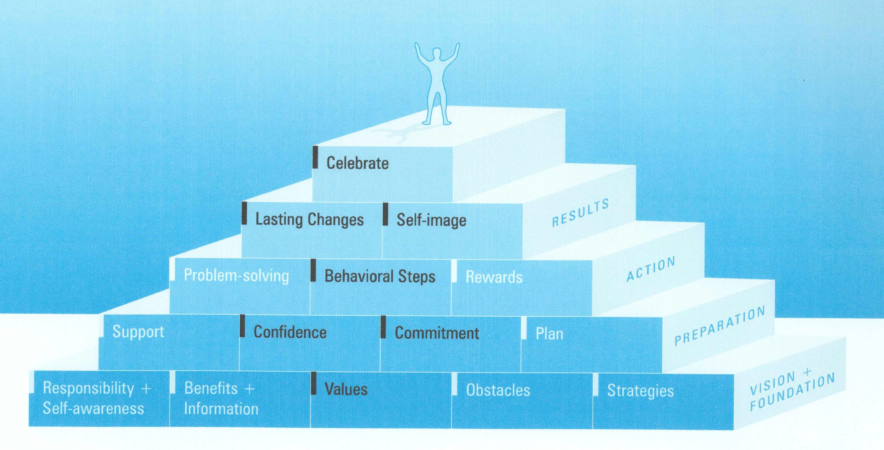

Basic Coaching Communication
Skills:
- Mindful/Active listening
- Open-ended questions
- Reflections
- Summarizing – to verify agreement on what is heard
- Silence – to allow thinking time
- Insight – seeing the bigger picture from a different vantage point
- Support – being there and available

Tools:
- Explore strengths, current or from past, to build confidence.
- Be totally non-judgmental in responses, regardless of what is heard.
- Change negative talk, from “I have to” or “need to” to: “I want to.”
- Accept fully & pleasantly any resistance; accept them where they are!
- Assist with realistic small steps in setting goals to build confidence.
- Explore strategies to overcome obstacles; brainstorm if needed.
- Use the scale 0-10 to determine their confidence &/or commitment.
- Always request permission for prayer, or when offering suggestions.
- Refuse to jump in with advice or personal experience.
- Recognize and agree with to refer to specialists.
- Affirm their good work and your desire to accompany them in their journey.
- Remind them all conversations and records are confidential.

Examples of some of these skills and tools:

1. Listening: The most important of all communication skills! It is nonjudgmental awareness of what someone is saying. There may be no other relationship in your friend’s life where they are heard in the way you hear them. As you pray with them you become closer. They feel vulnerable; so assure them of confidentiality. As you set aside your own agenda to listen closely, it is transformational for you both. “Listen until you no longer exist.” (Not I, but Christ!)
2. Silence: Give them thinking time. Don’t interrupt unless they are off track.
3. Change Talk: Encourage changes, without giving advice.
Tell me the best thing you did for yourself, no matter how small…
Tell me what you enjoyed most the past week, best meal, best day, or…
Tell me how you would go about making changes in order to succeed.
How important is it for you to make changes?
So what do you thing you will do?... What else?
4. Affirmations: This gives needed confidence.
You sound serious about making this change…
It appears that you are really trying to…
That takes a lot of…(courage, hard work, patience)
5. Summarizing: This helps them know they were heard – vital!
Okay, let’s see if I heard you right…
At this point, you’ve stated…
(They can trust you if they know you are accepting them where they are.)
Skills and Tools
Discovering Their Needs

You will often face an important challenge or opportunity during each coaching session this will be the “issue of the day”. This presents an opportunity for the coach to drill down to find the truth, the main point and help the client to resolve to take action.

Remember

- Clarify the main issue that the client wants to work on.
- Ask if this is an issue they would like to work on. (get permission)
- Begin a series of open ended questions, reflections, and discussion to help the client gain insight or awareness of the issues
- Help the client identify and commit to the next steps

How to identify their need

- The client has had a breakthrough, success and wants to build on it
- The client is unable to identify goals, motivators or feelings regarding wellness.
- The client is either held back from setting or meeting goals.
- They are, stuck, blocked, unsure, not committed, self sabotage, afraid to fail.

What to do once identified.

- Ask open ended questions, such as:
What do you want to do to overcome_______ or meet your goal?
What will it take for you to reach this goal?
What needs to happen for you to reach this goal?
What is the worst case scenario if you don’t achieve this goal?
What is the best case scenario if you achieve this goal?
What might be wrong/right about this goal?
What would it take for you to be ready to change?
What have you been successful with in the past in similar conditions?

- You may want to revisit the original vision, goals etc.
What are the top three values in your life? How is your wellness linked to these?
What part of your life is most important to you? How is your wellness linked to these?
What would you like less of in your life? How is that linked to your wellness?
How will these goals change your life?
What do you think is the best/worst possible outcome of our coaching program?

- Give client ample time to respond to any of your questions, don’t jump in to help with possible solutions or advice.

- Close the coaching moment discussion by having the client commit to specific action steps. State in their own words.
Remember:

- Use active listening
- Build rapport before starting the coaching moment process
- Use few words, simple questions and reflections
- Ask only one open ended question at a time.
- Its ok for them to be uncomfortable with the discrepancy of where they are and where they want to be.
- Silence is ok, get comfortable with it.
- Help your client commit to an action step.

How to help your client meet their goals

- Have a positive attitude at all times, believing they can do it.
- Understand and discuss the reasons for goals not achieved and develop new strategies.
- Make sure the goals are SMART goals.
- Be firm when the client is spinning their wheels and not being honest with it.
- Deal with self sabotage “ I get the feeling you might be sabotaging yourself by …. Do you think this might be true?”
- If they will not admit. “I think we have hit a wall here. What do you think?
- If they admit. 1. Identify the triggers that set them off course. 2. help them figure out how to avoid the trigger 3. help them with self esteem despite the trigger 4. help them work out a plan to stay on track even if the situation occurs again.
- Help them find a support system
- Help them learn from past failures.
- Brainstorm solutions that they seem to have no control over
- Tell them what has worked for another client.
- Celebrate success
- Not failures but obstacles. Lapses are part of being human.
- Admit if it your fault for their lack of success.

Coaching Inquiry and Awareness

The most common communication with a professional doesn't work because it focuses on providing:education, advice, goals, strategies, new skills, and prescribing a specific program

Coaches:
Guide the coaching process, by asking open ended questions
Focuses on the present with a view toward the future vision
Help client develop short and long term goals
Focus on the clients priorities, listen carefully to discover what they are
Hold the client accountable for what they commit to do
Help your client become more honest with themselves
Work toward independence, to sustain their new behaviors without you
help client figure out their values and goals by asking great questions
Through “coaching moments” they empower clients to find their own answers
through asking non-judgmental question they providing thoughtful reflections and discovery

Rules for a good coach

The client needs to work and speak at least as hard and as much as the coach
Use only one reflection at a time, speak less and simply
During the session ask yourself often what do they need most expert advice or coaching
Balance questions with reflections to avoid the feeling of an inquisition.
Use silence, it can help increase thinking and reflection

Awareness

We generally operate on automatic pilot, this is good for some things but makes bad habit hard to break because we are mindlessly doing them before we are able to stop ourselves. This can occur when eating, exercising, worrying. Instead of being more aware of what we are doing so that we may enjoy more or be more aware of why we do what we do.

Awareness is a way to break free from this autopilot and learn to pay attention to the present moment. We are able to do this by paying attention to our thoughts, feelings, behaviors, and environments. Through our questions we can have our clients pay closer attention so that they can make the appropriate changes to better achieve their goals.

For instance to be mindful while eating can help them eat slower and enjoy their meals even more and change their relationship to food. This allows them to make conscious decisions about their eating habits rather than blindly continue the same old habits.

We must become more mindful ourselves if we want to help our clients to become mindful. One way of doing this is to “show up” mentally for our coaching sessions. To be alert and in the present and not just going through the motions.

Sample questions for coaching inquiry:

What would you like your wellness to look like in three months, one year, five years...?
What would you like your life and wellness to look like in three months, or in one year?
What are the top three values in your life? How is your wellness linked to these values?
What are the top three goals in your life? How is your wellness linked to these goals?
What part of your life is most important to you? How does your wellness fit in?
What would you like less of in your life? How is that linked to your wellness?
What would you like more of in your life? How is that linked to your wellness?
What excites you? How can we link that to your wellness?
What would you like to accomplish in the next three months?
What motivators are important enough to you to enable you to overcome your obstacles and meet your goals?
What would your life be like if you achieve these goals? How would that feel?
What would your life be like if you do not this goal? How would that feel?
What is the best case scenario?
What is the worst case scenario?
What obstacles might get in the way of you reaching your goals and vision?
What strategies have you used in the past to overcome obstacles? What has/hasn't worked
What will it take for you to reach this goal? What needs to happen for you to reach this goal?
What will it take for you to make changes?
In the next week, what could you think about or do, that would move you forward?
What have you tried and succeeded to accomplish in your life that is similar to this goal?
What are some new possibilities that you haven't considered before?
What do you think is the best possible outcome of our coaching program?
What do you think is the likely outcome of our coaching program?
What do you think is the worst possible outcome of our coaching program?
What would you like the outcome to our coaching program to be?
What can I do to best help you today?
What might I do better to help you today?

Samples of questions to ask to help your client become more Mindful:

What are you thinking about as you are eating?
What does the food look, smell, feel, and taste like?
What did you learn about food from your family of origin?
Is food a substitute for comfort when you are feeling tired, bored or depressed?
Was dinnertime with your family calm or chaotic?
Did you share a meal with family members at all?

Motivational Coaching

Motivational Coaching is a method of coaching that enhances intrinsic motivation to change by exploring and resolving ambivalence.

It gets the client to express out loud the reasons for change, why they want to continue the process to reach the healthy behavior they want for themselves. The chances are better of them working on their goals if they have described the reasons in their own words.

The process is based on three elements needed to initiate and support change simplified as ready, willing and able. It compares the pros and cons of change or no change, and through the coaching skills of inquiry and reflective listening, the coach will guide the client into pro-change talk and attempt to diminish resistance to change through appropriate responses.

If used correctly this method of interviewing will cause the client to do most of the work to move forward. If this is not the case try to talk less and listen more. Remember that coaching is not about the coach it is about the client choosing the process of change with the coach working as the facilitator for that change process.

Pro-Change Talk

Clients are usually aware of what they could be doing for improved health, and for some reason they have resisted the behavior change they know they should make. If the coach directs the conversation so that the client describes their reason for changing (pro-change talk) instead of telling the client why they should change, the client then is doing the work and owning the solution leading to much greater success. Clients are much more likely to act on what they say, not what they hear.

- Ask open-ended questions – can’t be answered by yes or no.
  - What concerns do you have about your current behavior?
  - How might continuing your current practice lead to future health problems?
  - What do you eat during a typical day?
  - What changes would you like to make in your exercise habits?
- Affirm that they have the strengths available to reach their goals
- Restate or paraphrase
- Summarize what you hear

Reflective Listening

- Simple Reflection - restate what the client says

“I don’t have time to exercise. No one I know exercises much”
So all your friends are inactive. Do you not think it is possible to exercise without them
- Amplified Reflection – the coach exaggerates the clients statement
“So you couldn’t really start and exercise program because you wouldn’t fit in with your friends”
- Double-Sided Reflection – reveals mixed feelings (I don’t want… but I do…)
So you don’t see how you could exercise without your friends but at the same time you are worrying that not exercising will not be good for your health
- Shifting Focus – Don’t restate a resistant statement
Well were not quite there on the exercise, lets continue to look at other issues, we can return to the exercise at a later time.
- Rolling with Resistance – Don’t try to change their mind (It may just not work)
“You might find that the exercise issue is just going to be too difficult of a change to make at this time, that’s something that you will have to decide at some time.”
- Reframing – reflect in a new light to give new meaning to what they are saying.
My best friend is always bugging me to lose weight. It’s really irritating
Your friend must really care, wanting to help even though it may make you angry.
- Working with Resistance – paraphrase 2-3 times more than asking questions.

Don’t
- Parroting – simply repeating what is said, you need to include feelings
- No empathy – no change in tone regardless of clients feelings
- Move into giving advice, or solutions rather than to continue coaching
- Over Analyze – guessing on the meaning of the clients statements

Decision Balance: Compare the reasons to stay the same with the reasons to change.
What are the benefits of staying the same? , What concerns you about a change?
Resistance Score. (0-10)
What concerns do you have about staying the same? , What are the benefits of change? Motivation Score (0-10)

Exploring importance & Building Confidence

Importance:
How important is it for you to change _____________________ today?
(0-10) where 0=not important at all and 10= most important thing in my life now

Questions you can use to respond to the confidence scale score:

What would make you more confident about making these changes?
Why did you choose ___ and not a lower confidence score?
What would it take to make it a ____?
What have you learned from what went wrong last time you tried to change___?
How can I help you succeed in this?
Confidence:
How confident are you that you will succeed in____________?
(0-10) Where 0= I don’t think I can achieve my goal, and 10=I will definitely do it

Is there anything you can think of that would help you feel more confident?
If you were to decide to change what would some you options be?
Is there anything you have found helpful in any previous attempts to change?
(any of the important questions above)

Other Motivational Interviewing Skills

- Expressing appropriate empathy – non judgmental, accept ambivalence see the experiences through their eyes, understand their point of view.
- Developing discrepancy – to see the discrepancy between the current situation and the desired change. (what they are doing won’t reach their goal)
- Avoiding argumentation – change strategies, gently defuse their defensiveness, take their side in support of resistance.
- Rolling with resistance – invite them to examine new perspectives; value them as being their own expert.
- Supporting confidence in Gods desire for our success – that there is all the power to succeed in reaching a noble goal

Increasing Motivation & Confidence
Motivation
- Safe atmosphere
- Empathy
- Unconditional acceptance
- Facts with hope
- Weigh pros & cons
- Define the Why
- Honor values & beliefs
- Wellness visioning
- Readiness exercises
- Success stories

Confidence
- Make commitment
- Start small
- Add, rather than take away
- Have a flexible plan
- Build on previous success
- Anticipate obstacles
- Insights into behavior
- Affirmation & encouragement
- Use proven success strategies
- Cheerleaders
- Accountability
Sample Questions When Dealing with
Ambivalence or Resistance

What is happening when you feel …?
What are the triggers that are stimulating you to feel …?
What would it take to deal with your feelings of ….?
What is holding you back or standing in your way?
How is … holding you back?
What are you afraid of?
What is at risk for you?
What is more important to you than meeting this goal?
What would make this the right time for you to do this?
What is on your plate right now that may be getting in the way?
What would you like to do?
What are you able to do to overcome … or meet your goal?
What are you willing to do to overcome … or meet your goal?
What can I do to best help you today/in our coaching program?
What might I do better to help you today/ in our coaching program?
What would your life be like if you do not achieve this goal? How would that feel?
What would your life be like if you achieve this goal? How would that feel?
What is the best sce3nario if you achieve this goal?
What is the worst case scenario if you don’t achieve this goal?
What might be wrong about this goal?
What might be right about this goal?
What will it take for you to reach this goal?
What needs to happen for you to reach this goal?
What would it take for you to be ready to change?
What motivator is important enough to you to help you reach this goal?
What can you learn from this.
What is the solution here?
In the next week, what could you think about or do, that would move you forward?
What have you tried and succeeded to accomplish in your life that is similar to this goal?

SAMPLE COACHING QUESTIONS

Exploring is more comfortable if there is one reflection to two questions. Always use what, how, when, where. Why is often judgmental and you may learn little.

- What do you really want?
- What might happen?
- What do you think that means?
- What is just one more possibility?
- What would it look like?
- What else?
- What more is there?
- How do you want it to be?
- If you could do anything you wanted, what would you do?
- How can we explore this further?
- What will you take away from this?
- How can you lock in the learning?
- What options can you create?
- How will you know you have reached it?
- Now what?
- What do you want to do about it?
- What resources do you need to help you?
- What seems to be the main obstacles?
- What concerns you most?
- What action will you take?
- And after that?
- Where do we go from here?
- When will you do this?
- How will I know?
Reflecting: "So, what I hear you say is that you want to.......

C-Choice
Choice is the first step toward improved health because people who believe they are in control over their own lives are healthier and live longer.

R-Rest
Rest is good sleep and also taking time to relax. Relaxation lowers blood pressure and reduces stress.

E-Environment
Environment is our external world but also affects what happens within us for the better or worst.

A-Activity
Activity includes physical and mental conditioning. Our goal is to be active in mind, body and spirit.

T-Trust
Trust in God speaks to the relationship between spirituality and healing. A link exists between faith and wellness.

I-Interpersonal Relationships
Interpersonal relationships strengthen our well being. Social connection fortifies our resolve and improves our health.

O-Outlook
Outlook creates our reality. Our mind influences our body and our attitude impacts our health.

N-Nutrition
Nutrition is the fuel that drives the whole system. Small improvements and strategic substitutions produce profound results.

You are here for a reason. Come with us now and start living your life to the fullest.
Health Principles in Wellness Coaching

Topics to consider:
- Give health advice only with permission
- Go slow with lifestyle changes
- Don’t be the “medical expert”
- Use resources rather than verbal instructions

Only with permission:
In the presentation of health principles as it relates to wellness coaching it is critical to understand that these principles are given only “with permission” that is to say as we maintain the principles of coaching which is to help the client discover his goals and actions rather than just telling them all that they should do. However when the opportunity presents itself and you see that good sound information on health principles would be valuable for their progress you may ask them. “ Could I share a health principle that may help you with that problem you are working on?”

Go Slow:
And when you receive permission that is not a green light to start dumping on them everything that you may know on the subject nor to present all that they may need but to take them one step at a time and pick the steps with which you feel they can easily be successful.

That does not mean that you cant give them an overview or the big picture but that you will present it to them as a process to work toward and that small steps will be the best way to reach their ultimate goal.

Not a Medical Expert:
It is also important to avoid being the medical expert even if you are. This will help to avoid conflict with their health care provider and also to avoid liability issues. Most lifestyle concepts can be presented in a convening manner as a neighbor would share with a neighbor or “what do you think about this”

This would include the wording and terminology you use. Avoid using such terms as treatment, diet, hydrotherapy, vegan etc. instead use “what I do”, food you eat, hot towels, plant foods, etc.

References vs Verbal Advice:
Instead of giving verbal advice it is best to give published references as articles or books. That way you are not responsible for accuracy and liability of the information given as the authors have already taken that risk for you. I recommend Health Power by doctors Diehl/Ludington as a simple and accurate resource for anyone needing lifestyle information and direction. Even then it would be a mistake for anyone to try to immediately follow every recommended practice in the book if it were new to them.
Key Health Principles

- Balance
- Logic
- Restoration
- Disease Prevention
- Avoid Extremes

Balance:
Balance is not only important but is also attractive to most people. An easy acronym to remember to teach balance is NEWSTART which stands for Nutrition, Exercise, Water, Sunlight, Temperance, Air, Rest and Trust in God. This does help to keep us balanced as too often we can get focused on one thing such as nutrition giving the impression that if that is in line it will fix everything.

Another Acronym for balance is CREATION as used in Creation Health. This my fit into a coaching model as the first principle is Choice, then, Rest, Environment, Activity, Trust, Intimacy, Outlook, and Nutrition. I like this because it begins with attitudes and relationships then saves nutrition to last which is the one that is often the main focus for lifestyle.

Logic:
When I present these principles I often hear people say “This makes more sense than anything I have ever heard”. I believe that truth about the natural laws that God has put into place will resonate with the heart of man. However it is important to take the time to see the logic in these principles and present them in their simplicity.

Restoration:
It is always amazing to me how the body is able to be restored to health and often very quickly when we stop the destructive behavior and begin following proper lifestyle practices. A good way to bring hope to people is to tell them stories of those we know that have seen reversal of disease, these dramatic changes are seldom seen through the normal practice of medicine but only through lifestyle approach. However it is very important to make it clear that every one and every situation is unique, so yes give hope but with that critical qualification. The determining factors may be age, how long they have had the illness, how closely they follow the correct principles and even their mental attitude and even if all things are followed perfectly there are no guarantees. We can always promise improved health but they may not see the degree of success in the area they are desiring.

Disease Prevention:
Everyone has a story of someone like a George Burns who violates every health principle and still lives a long life and in contrast they can point to someone who does everything right and dies from cancer at a young age. They therefore conclude that it doesn’t make a difference so why try, you might as well enjoy life because you can’t control the outcome.

I have discovered that people love to here good news about their bad habits. In other words if they read 10 research papers on the effects of chocolate on their health and 9 were negative and one was positive they would remember and quote the positive one because it supported what they wanted to do. So unless someone wants to know truth you will not make a lot of progress even with accurate information. That is why coaching is so effective the client develops their own plans and goals when they are ready.

There is very good evidence for prevention and reversal of such diseases as heart disease, diabetes, obesity, hypertension for almost everyone who applies the wellness principles. There is also good evidence for improvement and reduced risk for most everyone with cancer, arthritis, digestive disorders and neurologic conditions.

Extremes:
When you are involved in health work you will invariably be introduced to many remedies that are so successful that you are tempted to apply them to everything. They say that the sign of a fanatic is that no mater what topic that he starts on you can be sure of the topic he will end up on.
You will maintain a more solid reputation and success if you are careful to maintain a balance. That does not mean a mixture of truth and error but truth in balance.
In presenting a topic start with topics that have good solid research and are not too strange sounding rather than odd sounding ones even if true.

Good Web Sites Regarding Diabetes
http://www.pcrm.org/search/?query_string=Diabetes
http://www.pcrm.org/health/prevmed/diabetes.html
http://www.pcrm.org/health/diabetes/tour_highlights.html
http://www.weimar.org/
http://www.drnedley.com/
http://drmcdougall.com/free.html

Good Web Sites Regarding Heart Disease

www.heartattackproof.com

QUICK TIPS IN COACHING EXERCISE and NUTRITION

Two or three ideas can be offered if they seem stuck - always with permission. Their control of choices is important for ownership and acceptance. You may want to review "Health Power" for brief guidelines to help their misinformation if you are not a health professional. Be creative, listen carefully - make notes on comments to explore later.

Exercise:
- Activity can be as important as structured routines.
- Explore limitations, medications, doctors' orders for blood pressure.
- Explore past successes or attempts in other programs.
- Encourage small steps to create confidence.
- It is helpful to ask first what they know about exercise, such as heart rate.
- Encourage stretching, deep breathing as appropriate.
- Assess fluid intake, support system, equipment available, as needed.
- Let the Spirit lead the questions, give no advice.
- Assist with SMART goals.

Nutrition:
- Explore habits of eating such as when and how.
- Explore family habits, preferences, special needs and culture.
- Ask what they know about healthy food choices.
- Be aware of fads, indulgences and well-meaning nutrition diets.
- Be alert to resistance in change and accept their choice graciously.
- If they have low self efficacy, prayer and Bible promises often help.
- Encourage simple planning to promote achievement.
- Let the Spirit lead the questions, give no advice.
- Assist with SMART goals.
QUICK TIPS IN COACHING
STRESS MANAGEMENT AND SPIRITUAL AREAS:

These areas are more complex, demanding high levels of divine help to accept others where they are. As always, ask permission to explore.

Stress management:
- Maintain patient listening and faithful caring to encourage exploration.
- Explore how past stress reactions have been handled and who helped.
- Gently ask about their habits, relationships and efforts to control stress.
- Explore where they are feeling stress, mentally, physically.
- Be alert to addictions, depression and medications taken.
- Ask if prayer helps reduce the impact of their stress.
- Assure them of confidentiality and ongoing support in their journey.
- Request extra prayer before planning vision & goals.
Spiritual area:
- Explore carefully where they are in their spiritual journey.
- Be very sure of good rapport and their openness before exploring with them.
- Warm tone of voice in questions you ask, be sensitive to their comfort.
- Assure them confidentiality and genuine support whatever they say.
- Explore family relationships spiritually, positive or negative.
- Explore gently what their picture of God is - see sample spiritual questions.
- Pray with them before they plan vision or goals in this area.
Cautions:
- Avoid getting caught up in emotional areas as these are above.
- Avoid temptation to make converts to personal view of coach.
- Avoid talking too much, coach should be less than 50%.
- Avoid being the "expert" instead of helping them find their own answers.
SAMPLE SPIRITUAL QUESTIONS

It is important and respectful to request permission when asking spiritual questions. When you have a good rapport and prayed with someone, they are usually willing to talk about their spiritual life. The purpose of the questions is to help them go deeper in their relationship with Christ. You might meditate on these questions yourself before using them.

- What spiritual experiences have you had recently? How would you like to share it?
- How do you cope with heavy issues in your life?
- What or who do you lean on if you feel alone and helpless?
- How do you tap into a higher power beyond your own?
- What difference does Jesus make in your daily life?
- What do you understand that Jesus wants to do in you and through you?
- How has scripture been a help to know Jesus and His desire for you?
- How has scripture impacted your life in the past year, in what ways?
- What choices can you make to enable more of God's presence in your life?
- What habits or concerns interfere with your time with God?
- What distractions really need to be cut away?
- What can help you cut away distractions, like chores, worries or fears?
- How can you integrate the Lord's presence into every area of your life?
- What difference would the visible presence of Jesus make in your decisions?
- What increase in spiritual power have you gained recently that you would like to share?
- What can you do to be confident in the reliability and power of the Bible for your life?
- How can you prepare your heart and mind to see Jesus in the Bible regularly?
- What is your understanding of what Jesus did on the cross for you?
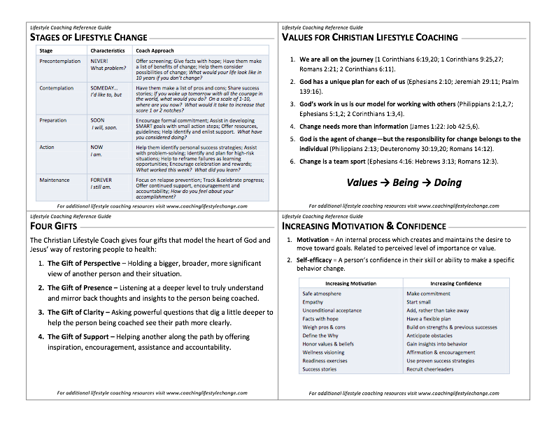
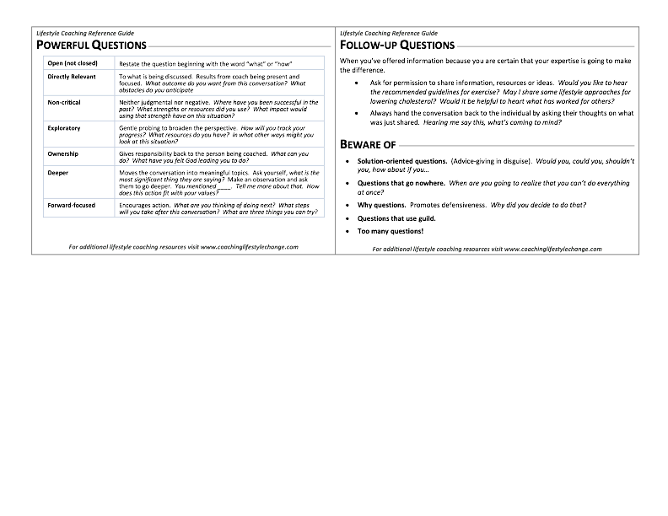
- How would you feel to realize Jesus is reaching out to you right now?
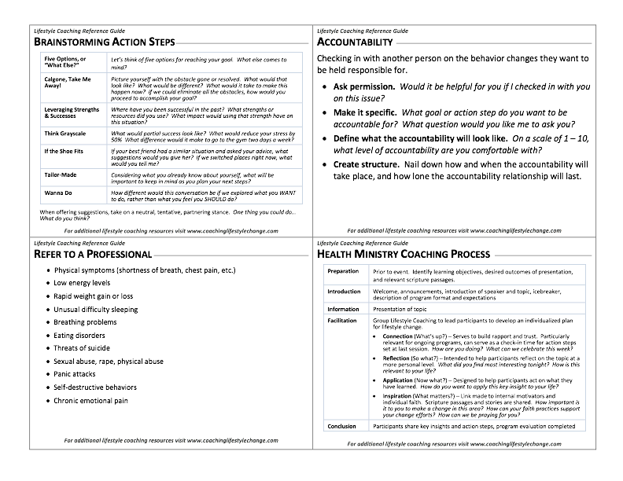
Recognition

These Coaching Resource Cards were developed by

Lilly Tryon, MSN, RN, FCN, cWC

You can enjoy more coaching instruction in Lilly’s complete coaching training program:
A Christian Approach for Coaching Lasting Lifestyle Change

T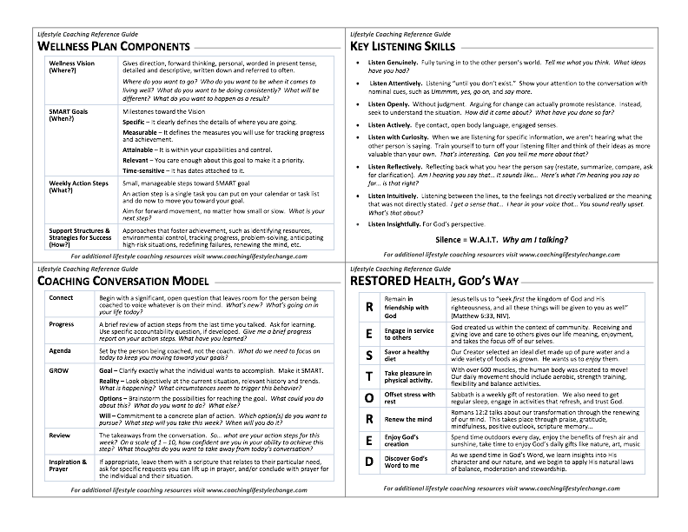
Recognition

These Coaching Resource Cards were developed by

Lilly Tryon, MSN, RN, FCN, cWC

You can enjoy more coaching instruction in Lilly’s complete coaching training program:
A Christian Approach for Coaching Lasting Lifestyle Change

